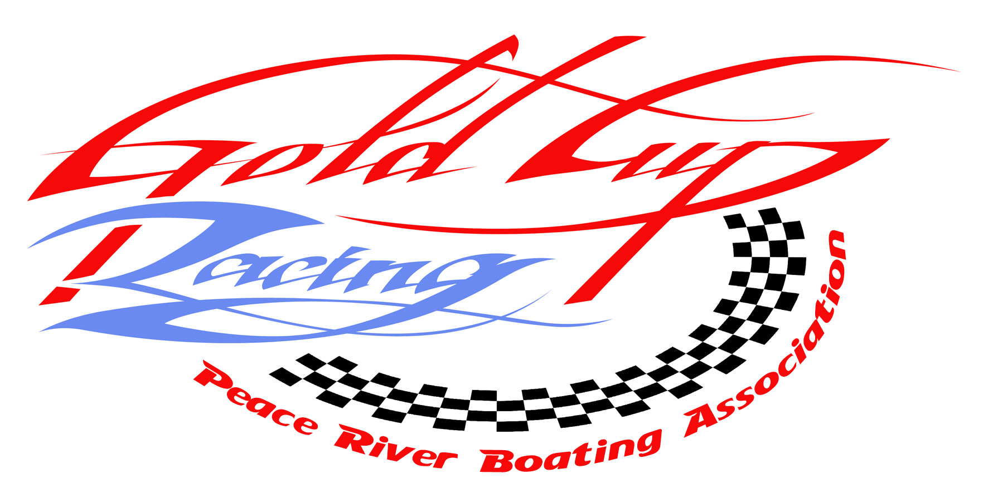
Racer Package
2009 Peace River Gold Cup Jet Boat Race

July 10, 11&12, 2009

Hosted by: Peace River Boating Association
Sponsored by: Glen Armstrong Construction

Registration / Technical Inspection / MANDATORY Show ‘n’ Shine
Registration at Riverfront Park in Peace River. Please park your boat at 97 St (close to Riverfront park), and WALK over the berm towards the river to registration booth.

Early Bird registration - $600 per boat. Registration form and ENTRY FEE must be paid prior to June 23, 2009 to receive early bird discount.

Registrations will be accepted until 1 hour prior to the drivers’ meeting on the first day of the race. Driver’s meeting will be held at 9 a.m.

Entry fees will be date stamped at time of receipt which will establish the order of starts for Leg #1.

Drivers / Navigators must have a valid CBF membership in order to race.
Tickets to the banquet/awards ceremony, and cut-rate tickets for the annual Peace Fest will also be available at registration.

NEW: All drivers are required to have a boat license, and all new drivers must have orientation course and driving test.

Class Sponsors:
Unlimited: Weaver Welding
A Class: Peace River Heating
B Class: Prairie Disposal
LS Class: Steed Grading
FX Class: MacMillan Construction
FX-V Class: Allen Bros Disposal

Prizes:
All entry fee monies will be paid out in prizes.
1st Place – 50%
2nd Place – 30%
3rd Place – 20%
$100 per leg for fastest time in class plus 1 trophy for each class on leg 3.

Race:
Maps of both legs of the race will be included in this package.

Leg 1 Saturday
Watino Bridge downstream on the Smoky river to Peace River.
Approx 55 miles
Leg 2 Saturday
Circuit race 4 laps 6 miles each.
Approx 24 miles

Leg 3 Sunday
Dunvegan bridge downstream on the Peace river to Peace River.
Approx 65 miles

Leg 4 Sunday
Circuit race 4 laps 6 miles each
Approx 24 miles

There will be a breakfast at Dunvegan on Sunday morning.

Launch
Racers only are to use the West Peace boat launch. Support boats use north end boat launch.

Banquet – Gold Cup Awards Ceremony & Canadian Series Awards Banquet
A banquet and awards ceremony will be held at the Sawridge Hotel (formerly the Travellers) on Sunday at 5 p.m. Extra banquet tickets will be available at registration.
The Canadian Series award winner will be presented with $5000 & 2 jackets from Outlaw Eagle Manufacturing. See Western Zone Jet River Rules.

Motors of the 1st, 2nd, and 3rd place boats in each class will be subject to a tech inspection immediately following the race. Do not leave the launch before you are told by the race captain that you may do so.

Protests:
All protests must be accompanied by $500, and must be submitted to the Race Captain. Do not speak to the timers regarding your times or a penalty will result.

UIM Rules for River Marathon Racing will apply! Know your rules.

ALSO INCLUDED IN THIS PACKAGE ARE:
RACE BOAT CHECKLIST RACE CLASSES MAPS OF RIVER.

ITINERARY

Friday July 10
4-10 p.m. Registration Tech Inspection Show ‘n’ Shine

Saturday July 11
9 a.m. Drivers meeting at Watino boat launch
10 a.m. Race to Peace River
1 p.m. Drivers Meeting at West Peace Boat Launch
2 p.m. Circuit race starts
Enjoy Peace Fest!

Sunday July 12
9 a.m. Driver’s Meeting at Dunvegan Boat launch
10 a.m. Race to Peace River
1 p.m. Driver’s meeting at West Peace Boat Launch
2 p.m. Circuit Race Starts
4 p.m. Tech Inspection
5 p.m. Awards Presentation

Please attach the sponsor decal to your boat that will be given to you at Registration. We value our sponsors.

For more information contact
Hal Bamping 780 618-8683 hal.bamping@shell.com
Gil Setz 780 618-1510 vmclaren@telusplanet.net
Daren Weaver 780 618-8828 wvrwldng@telusplanet.net

RACE BOAT CHECK LIST
Class______________ Date: _____________________

Boat Number
(2) Paddles/Oars
(1)3/8”x 50’rope attached hull/float device
(1)1/2”x 50’rope for towing
(1) 16” x 24” Red & Yellow Flag
Engine Restraints-3 point mounting
(1) First Aid Kit
(1) Tool Kit c/w tools
(2) 5 lb/2.25kg Fire Extinguishers
(2) Racing Life Jackets c/w leg straps
(2) Helmets-DOT or Snell 75Bright Color
Fuel Tanks Secure & Grounded
Bulkhead/Guards (if rotating parts
Reachable when belted in seat)
Throttle Return Spring
Blower Fan(Enclosed Engines)
Whistle
Bail Bucket
Flame Arrestor or Air Breather
Battery Disconnect – 3”red triangle sign
Accessible to racing crew
Fire Retardant Clothing
Water Outlets- Horizontally or Downward
Stop Watch
Roll Bar (well braced)
Steering Cables-center of hull or securely
Anchored
Mufflers
4 point seat belts with quick release
& tether connection between belt releases
Belt Cutter

Boat Captain _____________________________ Race technical inspector __________________________________

Race Class Rules 2009

The Canadian Boating Federation – Western Zone/ Jet River

Unlimited Jet Class – 300 Series Numbers (U300)
- Hull any shape or material with a minimum length of 16 feet (4.88m)
- Unlimited engine restrictions or modifications, any exhaust c/w mufflers
- Propulsion – jet drive
- roll bar (well braced & mounted)

“A” Jet Class – 200 Series Numbers (A200)
- Hull any shape or material with a minimum length of 16 feet (4.88m)
- Engine displacement shall not exceed 470 cubic inches (7700 cc)
- Superchargers, blowers & turbos are allowed at 1.8 x cubic inch ratio
- Engine shall use gasoline for fuel, any exhaust c/w mufflers
- Propulsion – jet drive
- roll bar (well braced & mounted)

“B” Jet Class – 151 to 200 Series Numbers (B160)
- Hull any shape or material with a minimum length of 16 feet (4.88m)
- Engine displacement shall not exceed 366 cubic inches (6000 cc)
- Superchargers, blowers or turbos are allowed at 1.8 x cubic inch ratio
- Engine shall use gasoline for fuel, any exhaust c/w mufflers
- Propulsion – jet drive
- roll bar (well braced & mounted)

“LS” Jet Class – 100 or 200 Series Numbers (LS100) (Canada Class) Test Class & Engine for 2009
- Hull any shape or material with a minimum length of 16 feet (4.88m)
- Engine shall be Chevrolet(LS Engines only) Ford or Dodge
- Supercharged, any carburetor, or fuel injection & engines for 2010 picked at end of season
- All engines must be factory crate engine & under 400 c.i.
- Engine shall use gasoline for fuel, no dry sumps allowed
- No porting, balancing or engine modifications allowed
- Any exhaust c/w mufflers
- Propulsion – jet drive
- roll bar (well braced & mounted)

“FX” Limited Jet Class – 01 to 99 Series Numbers (FX99)–Crate Motor Class
- Hull any shape or material with a minimum length of 13 feet (3.96m) No glass windshields
- Engine – Chevrolet ZZ4 355 HP crate engine. (GMPP long block part number 24502609) Rebuilt motors must meet OEM specifications & weights. A spec sheet must be filled out for any motor being rebuilt in this class (all specs the same as crate motor) max rebuild 0.030,any oil pan, no roller rockers allowed, No porting, balancing or modifications, Any Ignition, Sporadic Testing.
- Carburetor – 750 CFM max.carburetor & 1”spacer thickness max. 3-0.060 gaskets allowed
- Engines placing in the top 4 positions will possibly have to remove 1 cylinder head during teching after each race, all 0.030 over engines will have to remove 1 cylinder head “ALL GASKETS ETC. AT OWNERS EXPENSE”
- A spec sheet must be presented on your engine at race registration
- Any Racer caught cheating on this engine, the engine will be confiscated, sold & proceeds to charity, & banned from Canadian river racing for the next 3 races
- Exhaust – any exhaust system allowed c/w mufflers
- Engine shall use gasoline for fuel, no dry sump allowed
- Any dual plane intake manifold
- Propulsion – jet drive
- roll bar (well braced & mounted)
Western Zone Jet River Rules

- Point System for each CBF sanctioned Jet River Race
- 1st place – 25 points
- 2nd place – 23 points
- 3rd place – 21 points
- 4th place – 19 points
- 5th place – 18 points
- 6th place – 17 points
- 7th place – 15 points
- 8th place – 14 points
- 9th place – 13 points
- 10th place – 12 points
- 11th place – 11 points
- 12th place – 10 points
- 13th place – 9 points
- 14th place – 8 points
- 15th place – 7 points
- 16th place – 6 points
- 17th place – 5 points
- 18th place – 4 points
- 19th place – 3 points
- 20th place – 2 points
- 21st place – 1 point
- 22nd place – 0 points

- All points from each CBF sanctioned race to the BOAT OWNER

- Drivers may be changed for new races & only for medical reasons otherwise

- FX Class will be split between tunnels & v-bottom/step techs for the Canadian Races provided there are 3 boats for each class

- $100 per boat entry to be paid by each hosting club to Western Zone CBF for overall class prizes split 1st 50%, 2nd 30%, 3rd 20% & paid to the Boat Owner

- The Overall Canadian Winner will be based on total time for the season for all CBF sanctioned races; this will be sponsored by Outlaw Eagle Manufacturing. The winning boat will run a decal from Outlaw Eagle (Canada # 1) & the winning boat owner will receive $5000.00 cash & 2 jackets with their title & Outlaw Eagle Marine logos. The winning boat will have competed in all CBF sanctioned races.

- All new racers must have an orientation course & driving test, it is suggested that they start racing in FX Class

- “All boaters” Pleasure Craft Operators License effective September 15, 2009

- World Anti-Doping Alcohol Code in effect January 1, 2009. Suspensions will be issued after 0.03 blood alcohol levels.

LIST OF ACCOMODATIONS
PEACE RIVER
Hotels and Motels | Address | Phone | Fax
Sawridge (formerly Travellers) | 9510 100St | (780) 624-3621 | (780) 624-4855 |  | 1-800-661-3227
Peace Valley Inns | 9609 101 St | (780) 624-2020 | (780) 624-2099 | pvinns@telusplanet.net | 1-800-661-5897
Best Canadian Motor Inn | 9810 98St | (780) 624-2586 | (780) 624-1888 |  | 1-800-700-2264
Western Budget Motel | 7701 100th Ave | (780) 624-3445 | (780) 624-3544
Nova Inn (newer hotel) | 8010 100th Ave | ( 780 ) 618-1999 | (780) 618-2388 | www.novahotels.ca | 1-888-618-1999
Campgrounds
Lions Campground |  | (780)624-2120
Pine Ridge |  | (780)624-4603
Accomodation information:
Best Canadian Motor Inn is directly across the street from Peace Fest activities, the show 'n' shine, registration. It also has a small indoor pool.
Nova Inn is on the west side of Peace River and is newer.
Lions Campground and Pine Ridge campground are about 2 minute drive to the boat launch.
Call Lisa if you need more info. 780 618 6966
2009 Peace River Gold Cup
Sponsored by: Glen Armstrong Construction
Entry Form

Courier: Weaver Welding c/o Denis Cloutier 7501 107 Ave Peace River, Ab
Mail: PRBA Box 5264 Peace River, Ab T8S 1S7
or
Fax Entry to: 780- 624-2974

Registration, tech inspections, show ‘n’ shine
Peace River, Alberta. Riverfront Park July 10, 2009

==============================================================================

CLASS/BOAT # _____________________________ FX Class Only Hull type V—Bottom ____ Tunnel ____

BOAT NAME _________________________________________________________________________________

HULL MAKE/LENGTH___________________________________________________________________________

ENGINE MAKE/DISPLACEMENT /H.P. ________________________________________________________
____________________________________________________________

Driver Name: _______________________________Address:______________________________________________

Driver Contact info PHONE (home) __________________________ CELL#_______________________________

Email: _______________________________________ FAX #_______________________________

Navigator Name: _________________________ Address: __________________________________________

Navigator Contact info PHONE (home) ______________________ CELL #______________________________

SPONSOR (S) _____________________________________________________________________________________________________

PLEASE SEND BOAT PICTURES & PROFILES FOR PROGRAM
(lisa@wispernet.ca)
Deadline on program –June 23, 2008
Sanctioned by: APBA CBF

ENTRY FEE - RACE CLASSES - $700.00 PER BOAT CDN
Early bird $600 – Registration form and Entry form must be paid prior to June 23, 2009

