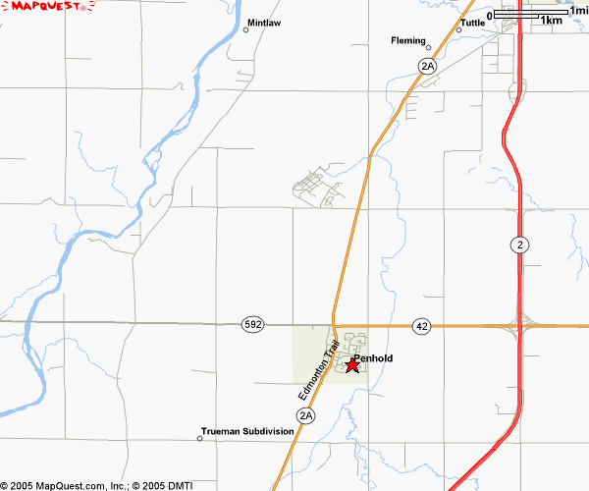
Ro

Off Hwy # 2
- Go west on the Pine Lake/ Penhold overpass
- There is a stop sign and a Fas Gas when you hit Penhold at the 2A intersection
- Continue west 6 km, you will pass the C&E Trail
- You will see a house with a big Red Roof on your right (unless it’s dark), start to slow down as you go past it as you will be going down into the river valley and the corner to turn right is as soon after this house.
- Turn Right on RR 284
- Our house is 1km down on the left….you will be able to see the riding arena and house as soon as you turn.(Yellow square on map)

Rob Chrunyk/Melanie Strome
Home Ph # 403-886-2592
Rob 403-318-0546
Melanie 403-391-7978

